Java Project - Intercity Bus Reservation System

Abstract

The Intercity Bus Reservation System is a Java-based project developed to make the process of booking bus tickets between different cities easier and more convenient.The main purpose of this project is to provide a simple system where users can view available buses, enter journey details, and reserve seats.The system allows the user to enter basic details such as source city, destination city, travel date, and number of seats.It helps users check the available buses and their basic details, such as bus number and seat availability.The system can calculate the total ticket cost based on the number of seats selected.After successful booking, the system displays the reservation details such as passenger information, bus details, seat number, and total fare.The project is developed using basic Java programming concepts such as classes and objects, conditional statements, loops, methods, arrays, and user input.The project helps students understand how Java programming concepts can be used to create a simple real-world application.Overall, the Intercity Bus Reservation System provides a simple and user-friendly way to manage bus reservations and reduces the need for manual booking.

2.Advantages
- Easy Booking – Users can book bus tickets easily through the system.
- Saves Time – It reduces the time required for manual ticket booking.
- Easy to Use – The system has simple options that are easy for users to understand.
- Reduces Manual Work – Bus reservation details can be managed without maintaining everything manually.
- Seat Availability – Users can check the available seats before booking.
- Accurate Fare Calculation – The system can calculate the total ticket cost based on the number of seats.
- Easy Record Management – Passenger and reservation details can be stored and accessed easily.
- Reduces Errors – Automated booking can reduce mistakes that may occur during manual entry.

3.Disadvantages
- Requires a Computer System – The system needs a computer or suitable device to operate.
- Requires User Input – Incorrect information entered by the user can result in incorrect booking details.
- Limited Functionality – A basic Java project may not include advanced features such as online payment or live bus tracking.
- Data Security – Passenger information needs proper security to prevent unauthorized access.
- System Failure – Technical problems or software errors may temporarily affect the booking system.
- No Real-Time Updates – A basic version may not automatically update bus or seat information in real time.
- Maintenance Required – The system needs regular updates and maintenance to work properly.

4.Implementation
1 .The Intercity Bus Reservation System is implemented using the Java programming language.
2.The system starts by displaying a simple menu through which the user can select different options related to bus reservation.
3.The user can enter the source city, destination city, travel date, and number of seats required.
4.The system checks the available buses based on the user's selected source and destination.
5.The user can select a suitable bus and choose the required number of seats.
6.The system checks whether the selected seats are available before confirming the reservation.
7.The total fare is calculated based on the number of seats selected and the ticket price.
8.After successful booking, the system displays the passenger details, bus details, seat number, and total fare.
9.Java concepts such as classes, objects, methods, arrays, loops, conditional statements, and Scanner for user input are used to implement the system.
10.The project is designed as a simple application to demonstrate how Java programming concepts can be used to develop a basic real-world bus reservation system.

5.Java code :

import java.util.Scanner;

public class BusReservation {
public static void main(String[] args) {
Scanner sc = new Scanner(System.in);

String[] buses = {"Bus 101", "Bus 102", "Bus 103"};
int[] fare = {500, 600, 450};
int[] seats = {20, 20, 20};

System.out.println("=== INTERCITY BUS RESERVATION SYSTEM ===");

System.out.print("Enter Source City: ");
String source = sc.nextLine();

System.out.print("Enter Destination City: ");
String destination = sc.nextLine();

System.out.print("Enter Travel Date: ");
String date = sc.nextLine();

System.out.println("\nAvailable Buses:");
for (int i = 0; i < buses.length; i++) {
System.out.println((i + 1) + ". " + buses[i] +
" | Fare: Rs." + fare[i] +
" | Seats: " + seats[i]);
}

System.out.print("\nSelect Bus (1-3): ");
int choice = sc.nextInt();

if (choice < 1 || choice > 3) {
System.out.println("Invalid bus selection.");
return;
}

int busIndex = choice - 1;

System.out.print("Enter Number of Seats: ");
int requiredSeats = sc.nextInt();

if (requiredSeats <= 0 || requiredSeats > seats[busIndex]) {
System.out.println("Seats not available.");
} else {
int totalFare = requiredSeats * fare[busIndex];
seats[busIndex] -= requiredSeats;

sc.nextLine();
System.out.print("Enter Passenger Name: ");
String name = sc.nextLine();

System.out.println("\n===== RESERVATION CONFIRMED =====");
System.out.println("Passenger Name : " + name);
System.out.println("From : " + source);
System.out.println("To : " + destination);
System.out.println("Travel Date : " + date);
System.out.println("Bus : " + buses[busIndex]);
System.out.println("Seats Booked : " + requiredSeats);
System.out.println("Total Fare : Rs." + totalFare);
System.out.println("Remaining Seats: " + seats[busIndex]);
System.out.println("=================================");
}

sc.close();
}
}

6.OUTPUT SCREENSHOTS:
1.Successful Resevation

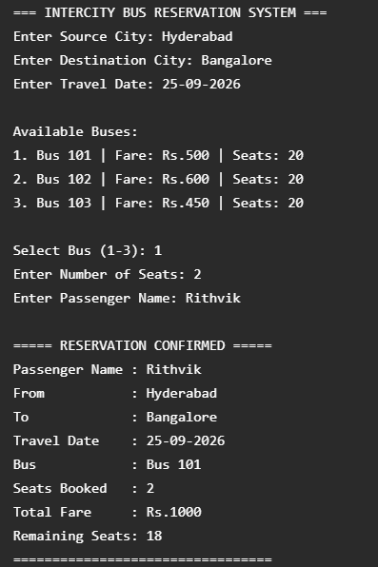

- Failed Reservation
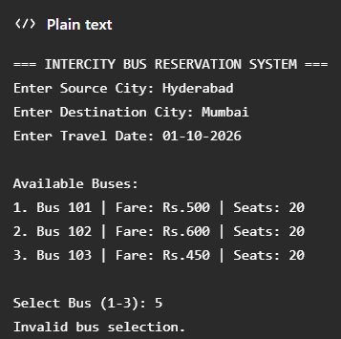

7.CONCLUSION:
The Intercity Bus Reservation System is a simple Java project developed to make bus ticket booking easier. The system allows users to enter journey details, select a bus, choose seats, and calculate the total fare. This project helped us understand basic Java concepts such as arrays, loops, conditional statements, methods, and user input. Overall, the project helped us improve our Java programming skills and understand how programming can be used to solve real-life problems.

